HIGHLIGHTS OF PRINCIPAL’S 4TH MARTICULATION SPEECH
Today, Monday 14th September, 2015, the Principal, Machakos University College, Prof. Francis M. Mathooko officiated the 4th Matriculation ceremony for the 4th KUCCPS intake. A total of 2, 901 students comprising of 2,546 degree students, 278 Diploma students and 77 Certificate students were admitted as bonafide students of the University College in 27 undergraduate programmes, 15 Diploma programmes and 6 Certificate Programmes. The event was attended by the Members of the University College Management Board, all Deans, Directors, Chairmen of Departments and Heads of Departments/ Section/Units.
In his speech, the Principal welcomed the students as they join a community of now over 8,500 students and advised them against engaging in vices that would lead to disruption of their studies. He told the students to appreciate the degree programmes to which they have been admitted because at the end of the day what matters is how one uses the knowledge and skills acquired.
He highlighted the new programmes scheduled to be launched in the 2015/16 academic year including:-
- B.Sc. (Telecommunication and Information Technology)
- B.Sc. (Actuarial Science)
- Master of Arts (Religious Studies)
- Master of Economics
- Master of Science (Human Resource Management)
- Ph.D. in Human Resource Management
- Ph.D. in Education, and
- Ph.D. in Business
He stated that, the University College is at the advanced stages of being accredited to a full-fledged university and expects to be granted the Charter within the next six months. He outlined the major milestones achieved in the last one year including:-
- Entering into Memorandum of Understanding with the Industry, notably being Kituluni Youth Polytechnic on youth education within the Machakos County
- Acquiring 45 acres next to the current location within the proposed Machakos City. This land was granted by the Machakos County Government
- The award of Ksh2,000,000.00 bursary from Machakos County Government to needy students studying in MUC
- The approval by the National Treasury of five (5) Public Private Partnerships funded by the World Bank that would immensely increase the University College’s accommodation, lecture theatres, hospitality and office capacities.
- Recruitment of Senior Members of Teaching Staff that would serve as thematic leaders for the proposed academic programmes expansions.
With the increased students population and with majority stay is off campus, he encouraged business people to invest in student hostels to cater for this increase.
He encouraged the students to utilise the numerous resources available in the University College both academic and recreational to advance their personal developments and academic pursuits.

PHOTOS
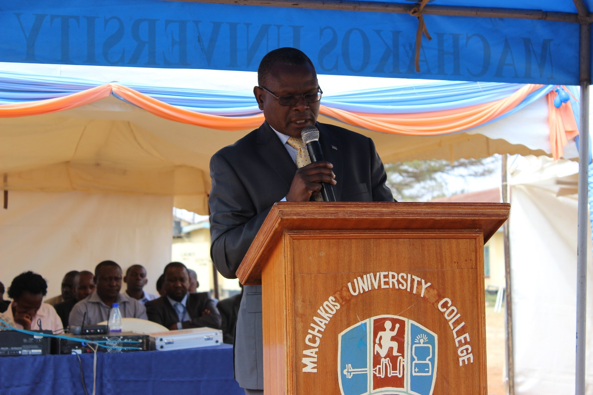
The Principal, Prof Francis M. Mathooko addresses the 4th KUCCPS MUC students during the Matriculation Ceremony

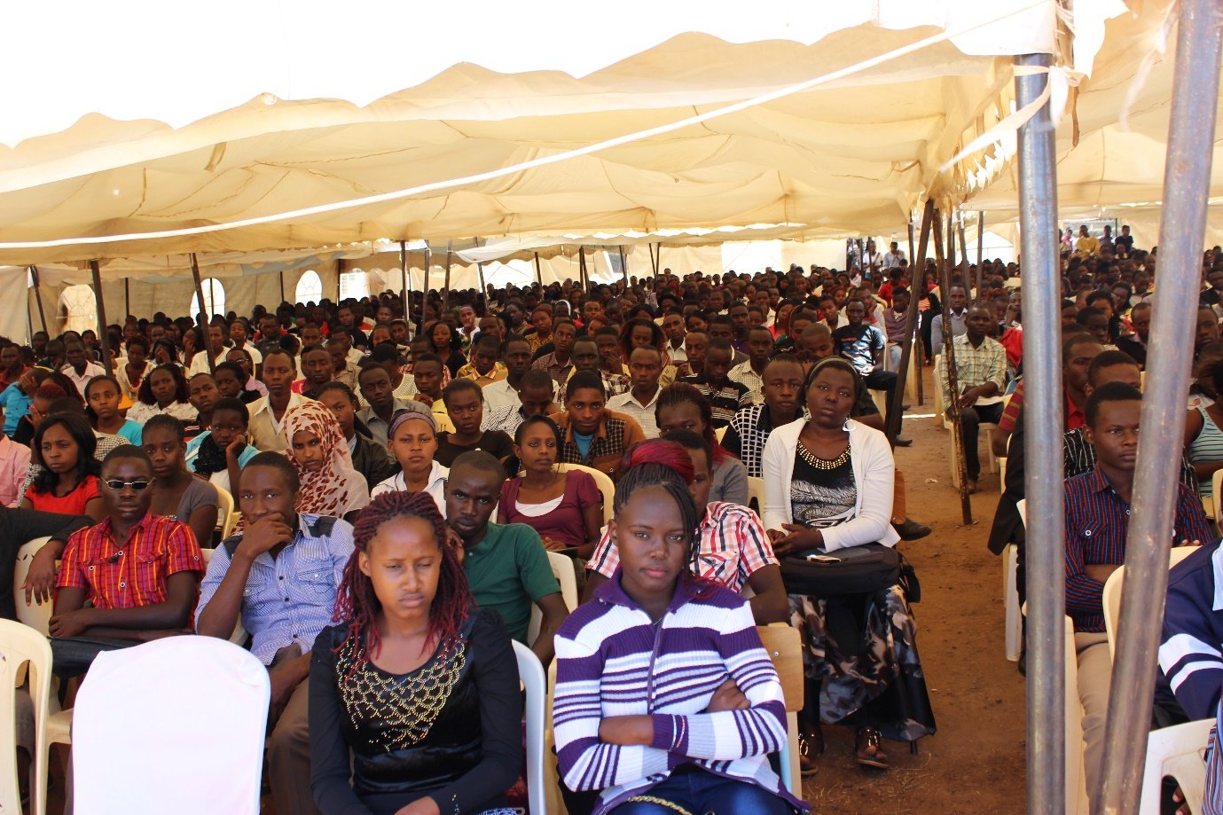
A section of the 2,900 strong students listening to the speeches

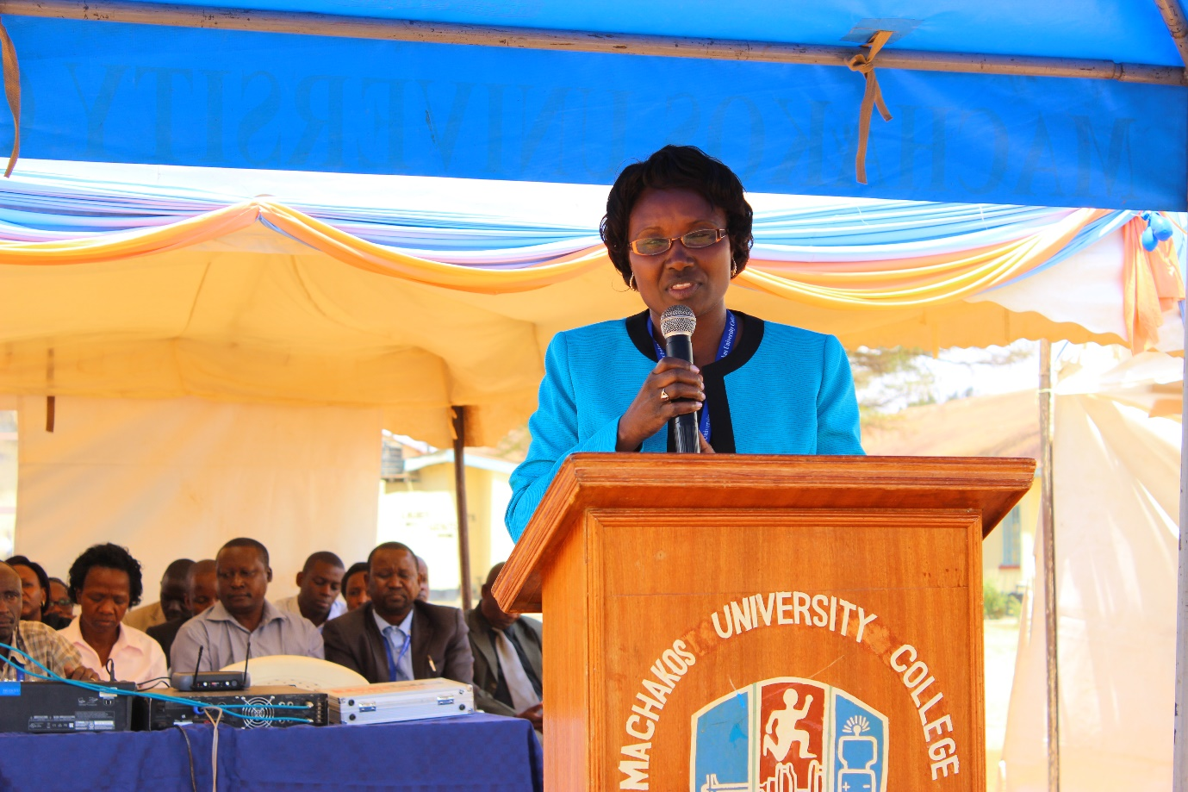
Deputy Principal (Academics, Research & Linkages) officiates the matriculation ceremony

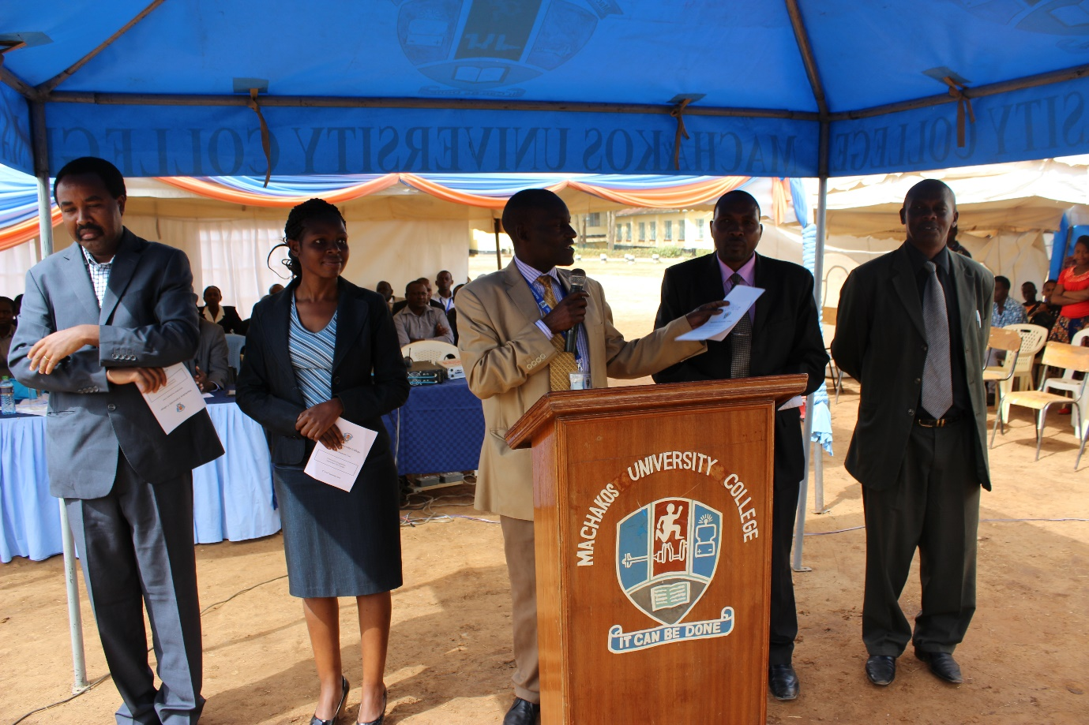
The Dean, School of Education, Prof. James Muola, administers the matriculation oath to the students admitted to programmes in the School of Education. With him are the Chairmen of Departments in the School of Education.
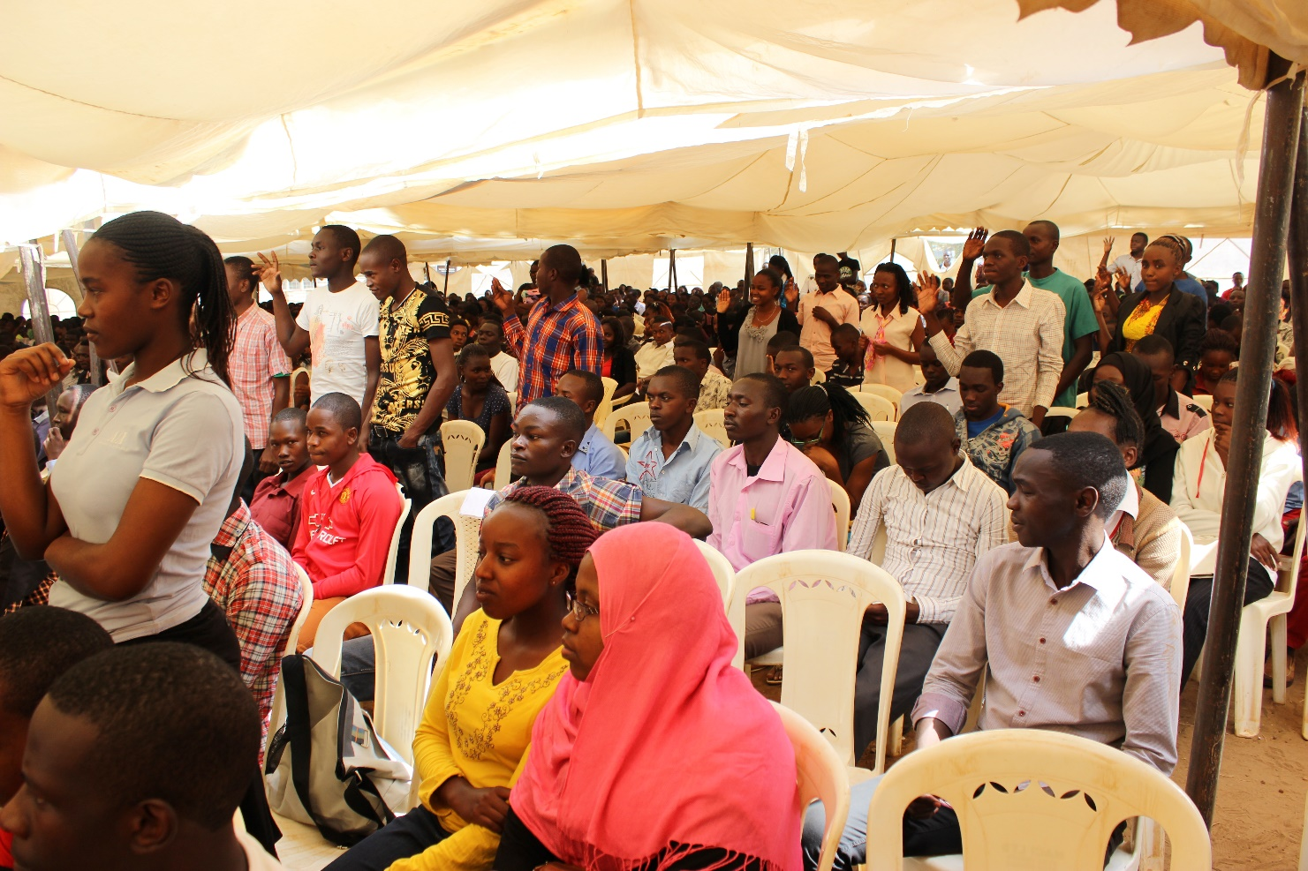
The students admitted to the School of Pure and Applied Sciences take their matriculation oath

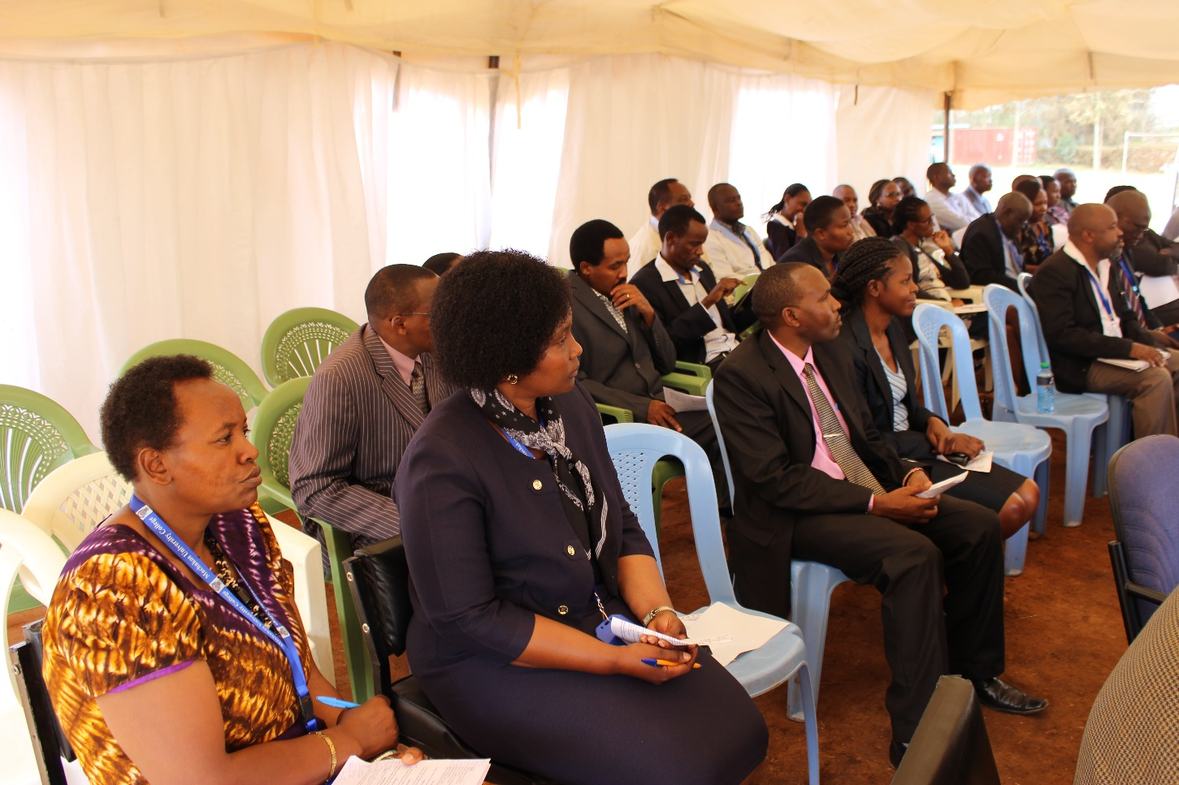
A section of the Deans, Directors Chairmen and Heads of Departments during the ceremony
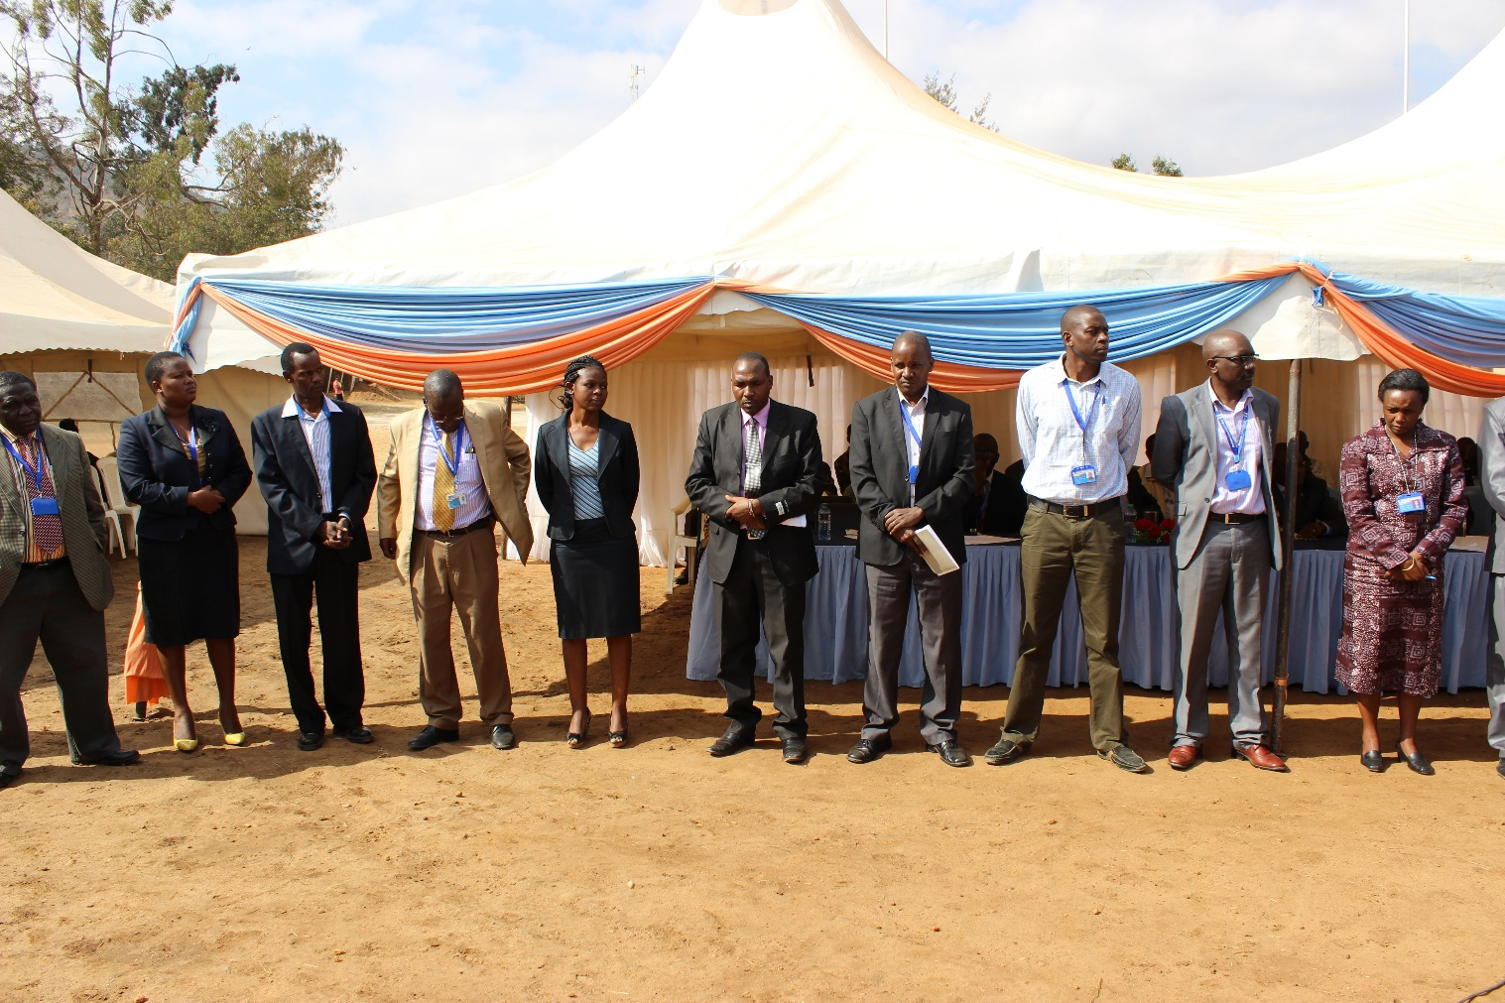
Deans and Chairmen of Departments are introduced to the students

